## 0Merchant

Demo date: Feb 5, 2025  
Scoping start date: Feb 17, 2025

MSA Signature Date: Feb 28, 2025  
Onboarding Kick Off Date: Mar 17, 2025

[If Exists] Opt Out Date:   
Go Live Date:

GTM POC: Paula  
Implementation POC: Royce

ERP: NS

Tax Integration: No Tax

### 

### Key people at Merchant

### Accountant: Tom <https://www.linkedin.com/in/thomas-dunworth-a335b39b> main user

### CFO: Jeff <https://www.linkedin.com/in/jeff-berry-4b41b334> champion

### Controller: Scott <https://www.linkedin.com/in/scotttruesdale>

* Account Receivable POC:   
  Markup Business- Val <https://www.linkedin.com/in/valency-horton>   
  Referral Business: Tom
* Billing POC: Tom and Val

### SFDC: Christine <https://www.linkedin.com/in/christinehooper>

* Snowflake / S3: Houston <https://www.linkedin.com/in/houstonslatton>

### 

| Notes Sections [Ops International Team to Ignore] *(AE/ Implementation to fill)*   * Info on how merchant bills   2 business motions: Markup and refferal  Markup: hourly rate or flat percentage Referral: Milestone billing. Takes a % fee   * Is there any important merchant relationship information? We will roll out on Referral business first bc they are considering bringing on a new hr tracking tool (currently tracking hours in NS) + they are in the process of rolling our Ramp. Markup biz has a remittance use case– we’re trying to push that onto the Ramp side to handle   Milestone billing- a major reason they purchased us is due to our ability to auto-update invoices based on milestone completion   Dunning- they use Tesorio and like it but they’re open to switching to us. We framed it as a later stage (potentially Q3- didnt promise this) design partnership   They will need a Customer / subcustomer set up for Referral business:  Customer- Service Provider Sub customer- Client engagement  Products- Milestones   Netsuite projects- they currently have netsuite projects set up to accommodate for Milestone billing but they will be getting rid of this as we will handle the milestone billing and revenue recognition.   SFDC- they dont want to push anything to SFDC from Tabs. They want us to send Tabs data → S3 bucket   1) What is the merchant temperament? Everyone is really nice but VERY quiet. They’re not reactive at all on calls but they’re actually just listening and absorbing. They typically have delayed reactions. Jeff is the most vocal. Jeff is very understanding and easy to work with. He’s a SUPER strong champion. They appreciate when you bring energy !   2) Is there a key POC: (i.e.: who is the buyer/decision maker?) Jeff but he really cares about what the team thinks, particularly Tom  3) What are the Tabs features that the key POC cares about?   1. Milestone billing- auto update of invoices when milestone completion documentation is ingested into Tabs 2. Automatic invoice creation 3. Cash app- val is doing manual cash app 4. Dunning - later down the line they’ll want to replace Tesorio |
| --- |

### 

### Company summary *(AE to fill)*

Summary of what company does:  
  
​BluWave is a company that connects businesses, particularly private equity firms and their portfolio companies, with a vetted network of specialized service providers. Their platform combines artificial intelligence, technology, and data with consultative support to match clients with experts in areas such as due diligence, value creation, and preparation for sale

Goals (North star)  
*(AE/ Implementation to fill)*

What is the merchant's goal? What pain are we solving? Why are they buying Tabs?

Pains:  
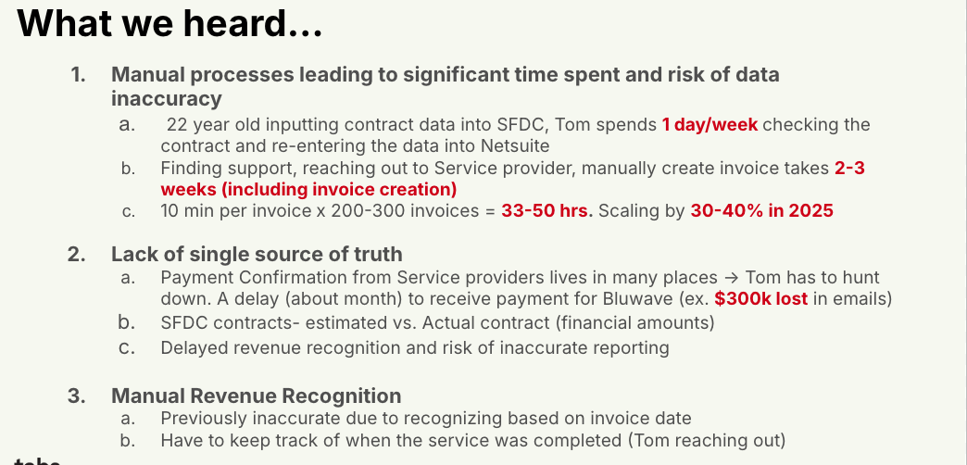  
  
Manual Cash app- Val doing manual application in NS today  
  
Is there an opt out clause? If so, what is the merchant looking for so they do not exercise it?

No

### Billing model *(AE/ Implementation to fill)*

* Are there unique things about the customer creation process for this merchant?  
  They will need a Customer / subcustomer set up for Referral business:   
  Customer- Service Provider  
  Sub customer- Client engagement   
  Products- Milestones
* Information on how merchant bills  
  See above

For the referral business, there are 3 players involved. The Service Provider, the Client, and BluWave.

* The Service Provider bills the Client
* BluWave bills the Service provider

There are 3 main document types to inform billing:

* Referral agreement between the SP and BluWave- this informs how much of a percent BluWave will take of the work billed to the client
* MSA/SOW between the SP and client- informs milestones for an engagement and how the billing will take place such as estimates for dates and revenue
* Support (i.e. emails, excels, pdfs,etc) between the SP and the client- this is how much the SP bills the client and informs the ACTUALS of how much BluWave can take a portion out of

In Tabs we are only tracking revenue between the SP and BluWave, therefore it should only be recognizing revenue for the referral percentage.

* How contract is broken up  
  See above
* One off things to know about the merchant  
  See above

### Contract Processing Steps *(Implementation/Success to fill)*

1. Steps to process
   1. BluWave's customers are Service Providers, who each have a referral agreement with BluWave. BluWave invoices each Service Provider for a % of the amount that the Service providers invoice their customers. Contract processing instructions:
      1. Only create products on the sub-customer level. To do this, we need both the contract that's stored on the subcustomer level AND the referral agreement that's stored on the parent level
      2. The parent customer may have multiple documents, but we only need to use the one titled <Customer Name> Referral Agreement. This should always be the same template and will have a referral % defined in a table at the top of the document
         1. Take this % and multiply the price of each product on the child level by that amount
         2. For example, Parent:Child A
            1. The child-level contract says they'll invoice $1000 for milestone 1
            2. The parent-level referral agreement says the referral percentage is 15%
            3. We would create a Milestone 1 product for Child A with price: 150
   2. Service Start Date: Locate the "Effective Date" or project start date in the Statement of Work (SOW) or contract document.
   3. Months of Service: Identify the contract duration by checking the initial term.
   4. Item Name: Look for the title of the project, service, or software solution being provided.
   5. Item Description: Leave blank.
   6. Integration Item: Leave blank.
   7. Billing Type: Determine whether the contract follows a fixed fee, milestone-based, or performance-based pricing model.
   8. Total Price: Locate the total fees, including any breakdowns by phases, resources, or cost structure.
      1. When a service provider’s SOW includes both a low and a high range for invoice estimates, default to the low range
      2. When sub-customer contracts have overly granular detail on line items, bluwave does not need all of this info. If possible, they'd prefer to use summary-level groupings from the document to create products instead.
   9. Quantity: Identify if the contract specifies a number of licenses, service units, or hours allocated for the project.
   10. Start Date: Confirm the official commencement date from the agreement.
   11. Periods: Determine whether the project is structured as a one-time engagement, recurring service, or an ongoing retainer.
   12. Frequency: Identify how often invoices are issued.
   13. Billing Timing: **bill last of period** as the default
2. Anything to ignore in contracts?
3. Specifics processing things the merchant has requested that may differ by contract (e.g. always back-date invoice date to final day of the month)
4. Default Service Term
   1. If None Listed, Ops Default is 1 Year
5. Default Net Payment Terms
   1. If None, Ops Default is 0
6. Default Billing Frequency
   1. If None Listed, Ops Default is Monthly
7. How do we handle taxes as a line item?
   1. If None Listed, Ops Default is every tax line item becomes a BT

### Events Processing (if necessary) *(Implementation/Success to fill)*

* Any important information on events billing

Integration Items Processing (if necessary)  
*(Implementation/Success to fill)*

* What are the instructions for assigning integration items?
* Example: All Statsig integrations items should be labeled as “Sales”
* Example: All “Pinata” integration items should be labeled as “Software Subscription Bundle” unless otherwise noted by Merchant

Post Processing Communications (if necessary)  
*(Implementation/Success to fill)*

* Does the Ops Team need to notify anyone on the team re: completion of processing batches in Implementation or Active phase?
* Who needs to be notified and when?
  + Example:
    - Who: Customer Success [Azmat Aziz] needs to be notified
    - Where: Messari internal merchant channel
    - When: contracts are processed [Merchant Phase: Active]

### Customer Information *(Implementation/Success to fill)*

* Any important information on specifics customers of this merchant
  + Special memo’s certain invoices require
  + Invoice changes due to merchant/customer relationship

### Feature Requests *(AE/Implementation/Success to fill)*

* FR 1
  + What is it
  + Why it's important
  + Urgency

### Rewatch Calls *(AE/Implementation/Success to fill)*

* Disco   
  <https://us-56595.app.gong.io/call?id=3068580645248676864>
* Custom Demo  
  <https://us-56595.app.gong.io/call?id=662713242741730445>
* Demo feedback   
  <https://us-56595.app.gong.io/call?id=4837951014932591331>
* NS Scoping   
  <https://us-56595.app.gong.io/call?id=3019649572402883206>
* SFDC Scoping  
  <https://us-56595.app.gong.io/call?id=7788091213121386800>
* Solutions Dry run   
  <https://us-56595.app.gong.io/call?id=2680703784817091416>
* Technical Solutions Presentation   
  <https://us-56595.app.gong.io/call?id=2607662941098577658>
* Partnership- implementation, CS, pricing, ROI   
  <https://us-56595.app.gong.io/call?id=1935952502197590868>
* Negotiations   
  <https://us-56595.app.gong.io/call?id=7195472802035490700>
* Required Capabilities Workshop   
  <https://us-56595.app.gong.io/call?id=1784998193930395587>
* Custom demo for Tom testing out invoices   
  <https://us-56595.app.gong.io/call?id=8594379417957792457>
* Negotiations pt 3   
  <https://us-56595.app.gong.io/call?id=1747923342785272927>